Report on “Conservation of Elasmobranchs with emphasis on the protected species under the Indian Wildlife (Protection) Act and CITES listed species” on 19.09.2018 at ICAR–Tuticorin Research Centre of CMFRI
ICAR-Tuticorin Research Centre (TRC) of Central Marine Fisheries Research Institute (CMFRI) organised a one day awareness program on “Conservation of Elasmobranchs with emphasis on the protected species under the Indian Wildlife (Protection) Act (IWPA) and the Convention on International Trade in Endangered Species of Wild Fauna and Flora (CITES) listed species” to the active coastal fishermen from different coastal fishing villages Thoothukudi District and nearby areas. Dr. P. P. Manojkumar, Principal Scientist & Scientist-in-charge, Tuticorin Research Centre, ICAR-CMFRI welcomed the gatherings and addressed the emphasis on the need for conservation of protected species of Elasmobranchs under IWPA and listed under CITES. He narrated that Elasmobranchs have very good commercial value due to its high priced fins; cartilage, intestine, teeth, liver, gills and meat are used for various preparation of medicines, ornamentals and a number of other items. He insisted that the declining of elasmobranch population is mainly due to their ultra low fecundity and longer maturation period compared with the bony fishes and shell fishes. He further stated that the Elasmobranchs species listed in the Wildlife (Protection) Act, 1972 in the Schedule I, Part IIA Fishes. He highlighted that CITES is an international agreement between governments where India is signatory of which aims to ensure that international trade in specimens of wild animals including Elasmobranchs and plants does not threaten their survival. He highlighted that Elasmobranchs species like sawfishes is listed in the Appendix I whereas other sharks and rays are listed in the Appendix II. Five species of sharks and all manta rays were added to Appendix II at Bangkok (Thailand), CITES at the 16th Meeting of the Conference of the Parties (CoP16), in 2013. These include the oceanic whitetip shark, the porbeagle shark, scalloped, smooth and great hammerhead sharks, as well as the great and reef manta rays. In addition, few elsamobranchs were also included in Appendix II of CITES at the 17th Meeting of the Conference of the Parties (CoP17, Johannesburg) in 2016. The species like silky shark, all the thresher sharks and all the devil rays are joined other sharks, rays and sawfishes listed in CITES. As of October 2016, twelve species of sharks, all manta and devil rays are included in Appendix II, and none in Appendix I. However, all species of sawfishes are in Appendix I.
Dr. I. Jagadis, Principal Scientist, ICAR-Tuticorin Research Centre of CMFRI outlined the program and enlighten the fishermen to utilise the expertise available at CMFRI during the course of the awareness workshop. Shri. Vimal Raj, Forest Ranger, Thoothukudi district, Tamil Nadu State Forest Department inaugurated the function and appreciated the importance of the program. Further, he delighted the effort taken by ICAR-CMFRI for the welfare of coastal fishers on the identification of scheduled Elasmobranchs under the Indian Wildlife (Protection) Act, 1972 and appendix listed under CITES. He also highlighted various infringement and punishments for the capture and trade of such species listed under protection laws. Mrs. Anju, Assistant Director, Marine Products Export Development Authority (MPEDA), Regional Office, Thoothukudi felicitated the function and narrated the export oriented information on banned Elasmobranchs.
A series of lectures (in Tamil) on field level identification keys and with emphasis on the protected species under the Indian Wildlife (Protection) Act (IWPA) and the Convention on International Trade in Endangered Species of Wild Fauna and Flora (CITES) listed species highlighting conservation of Elasmobranchs were given by the Dr. P.P. Manojkumar, Principal Scientist, Dr. L. Ranjith and Dr. C. Kalidas, Scientists of this centre to the fisher folks. The participants were given with colour charts of protected Elasmobranchs listed under Indian Wildlife (Protection) Act, 1972 for enable them to identify and release of the protected Elasmobranchs entangled or captured in their fishing nets accidentally. A discussion session on fishers view on the species listed under IWPA and CITES was also conducted and the points raised by fishers were noted for future course of action. The training program was co-ordinated by Dr. P.P. Manojkumar, Principal Scientist, Dr. I. Jagadis, Principal Scientist, Dr. L. Ranjith and Dr. C. Kalidas, Scientists. The awareness workshop was attended by 40 fisher fork form 8 different coastal fishing villages Thoothukudi District and nearby areas. The program ends with the vote of thanks by Shri. D. Linga Prabu, Scientist. The program was widely covered in print media.
**********
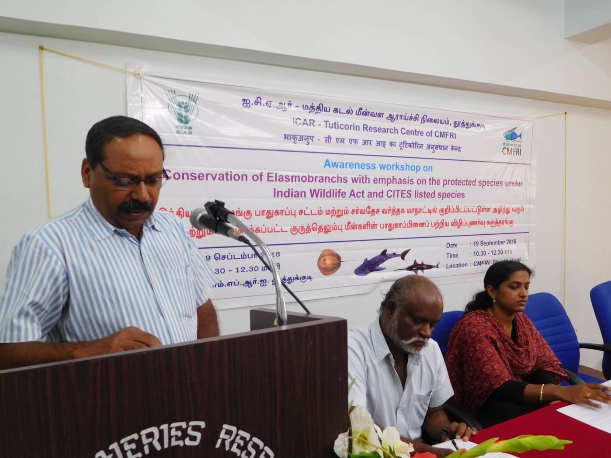
Dr. P. P. Manojkumar, Principal Scientist & Scientist-in-charge of ICAR-TRC of CMFRI welcomed the gatherings
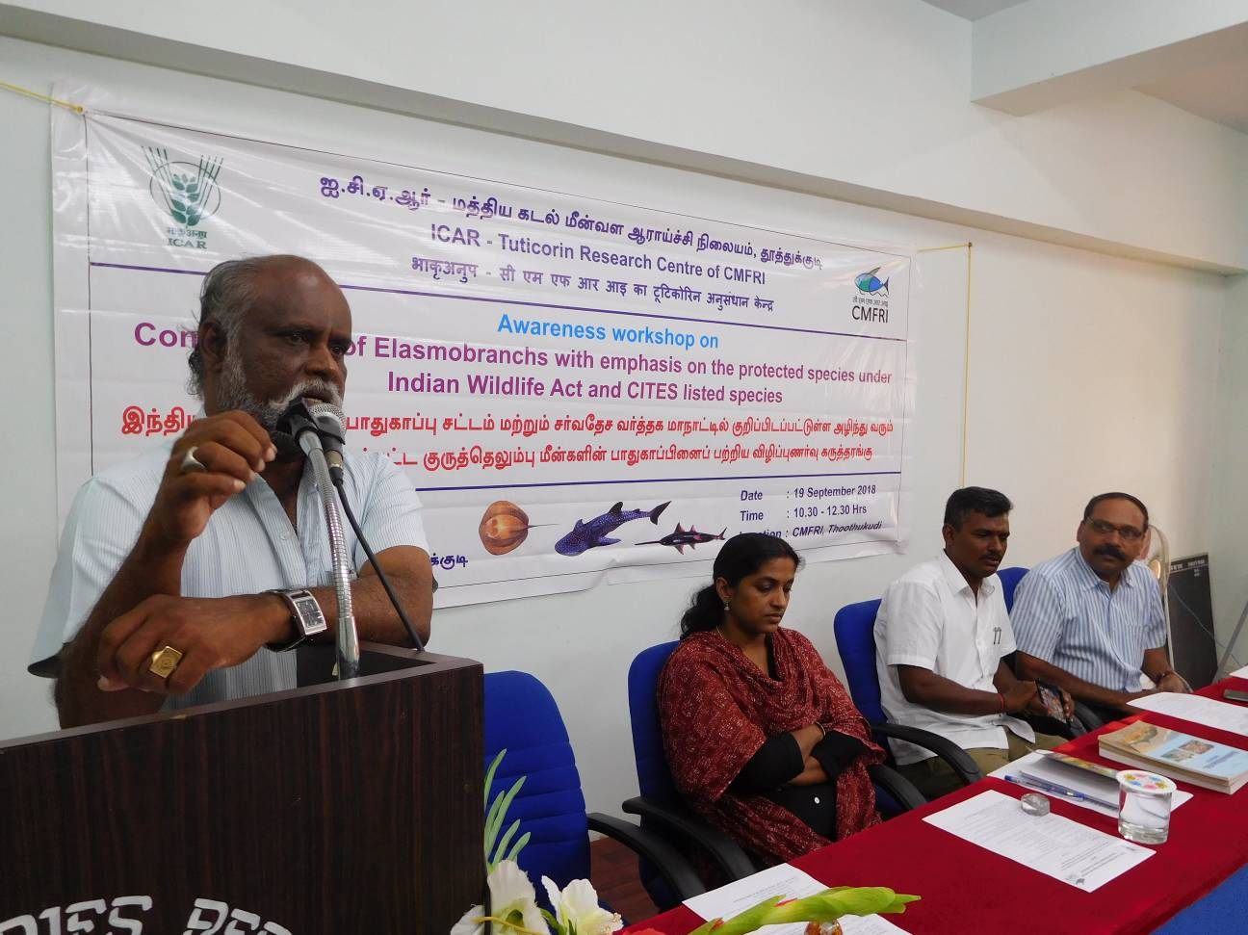
Dr. I. Jagadis, Principal Scientist, ICAR-TRC of CMFRI, Tuticorin delivering the program outline

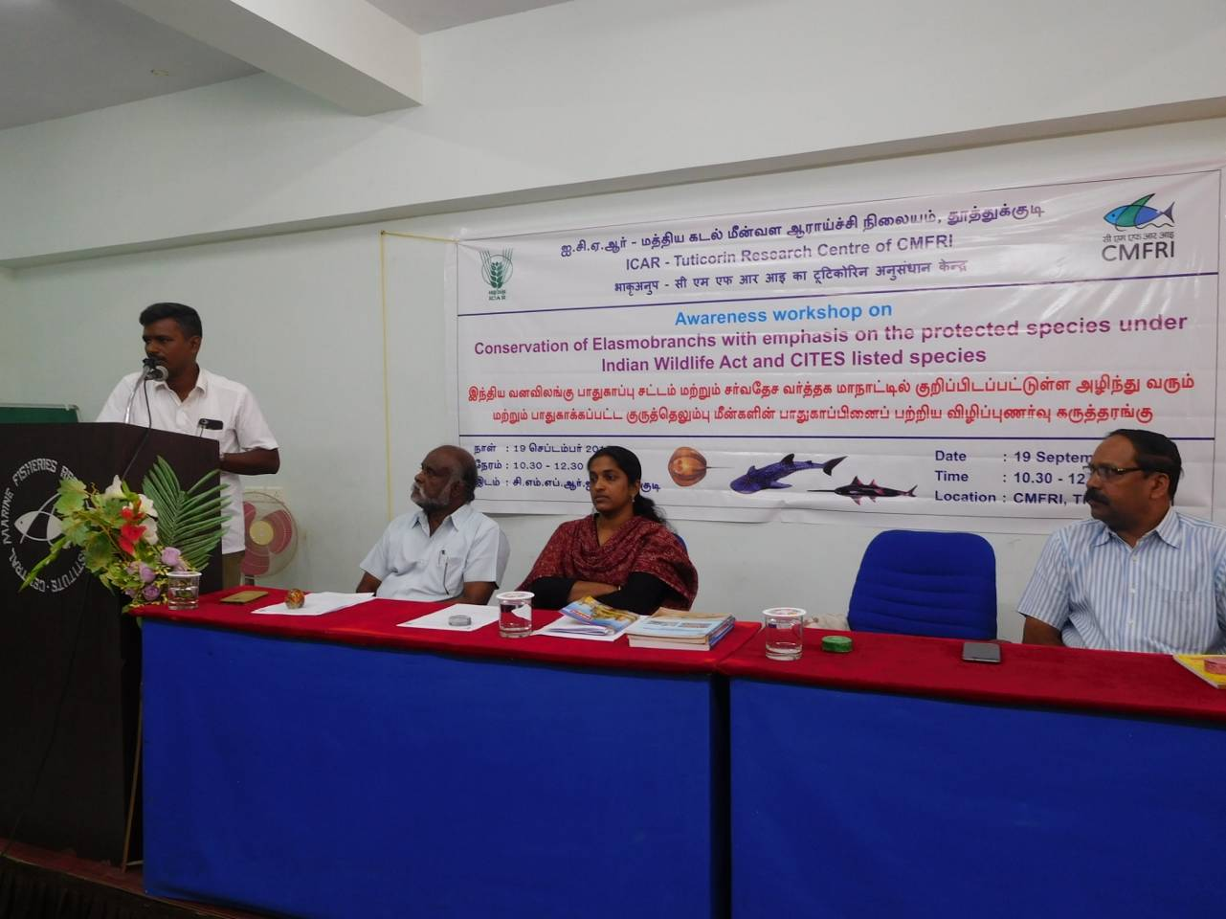
Shri. Vimal Kumar, Forest Ranger, Tamil Nadu Forest Department delivered the Chief Guest address
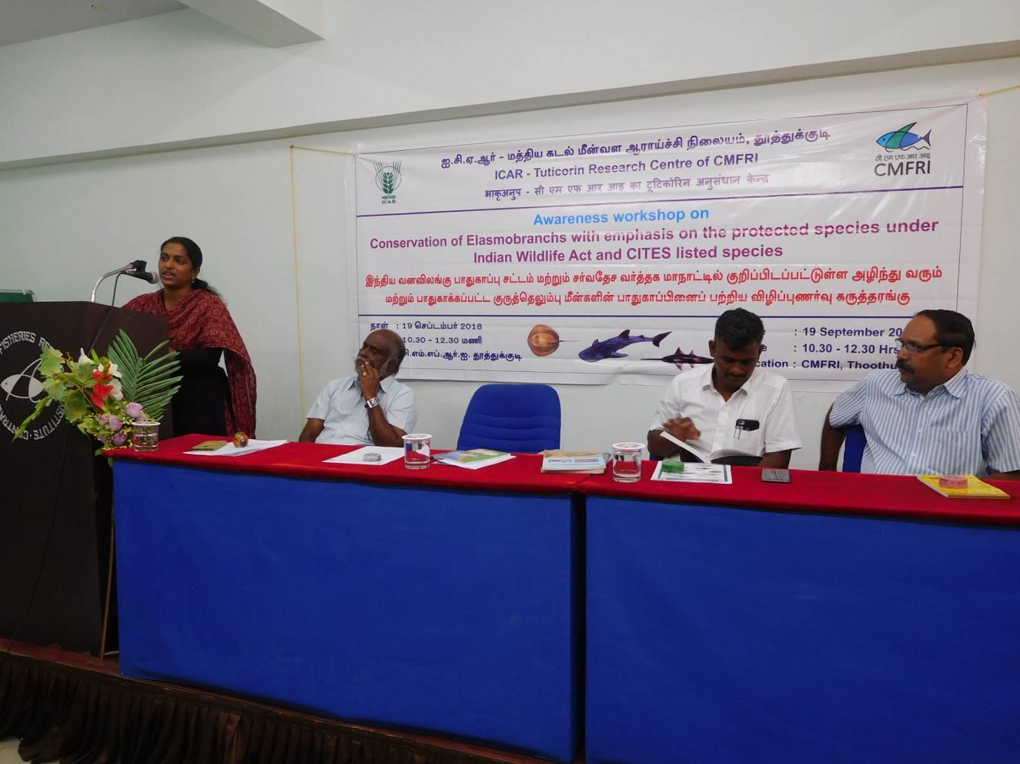
Smt. Anju, Assistant Director, Marine Products Export Development Authority, Thoothukudi Regional Office, Thoothukudi addressing the gatherings

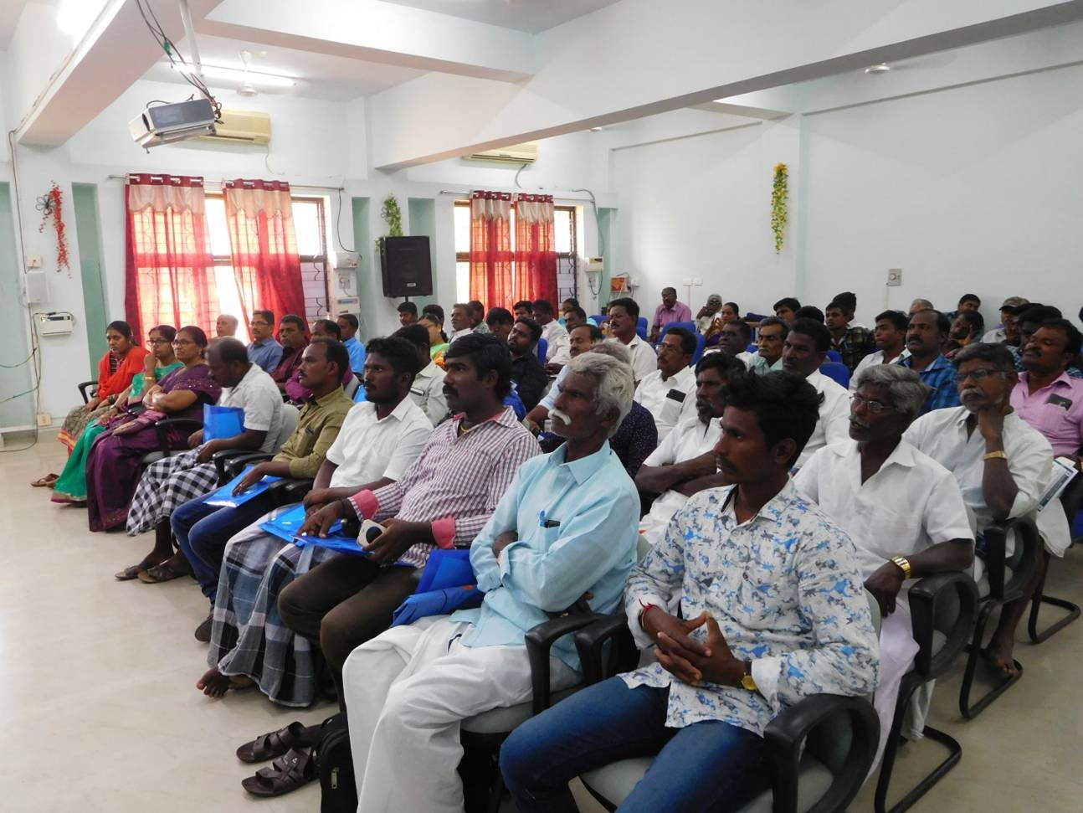
A view of the fisher folks attended the awareness workshop

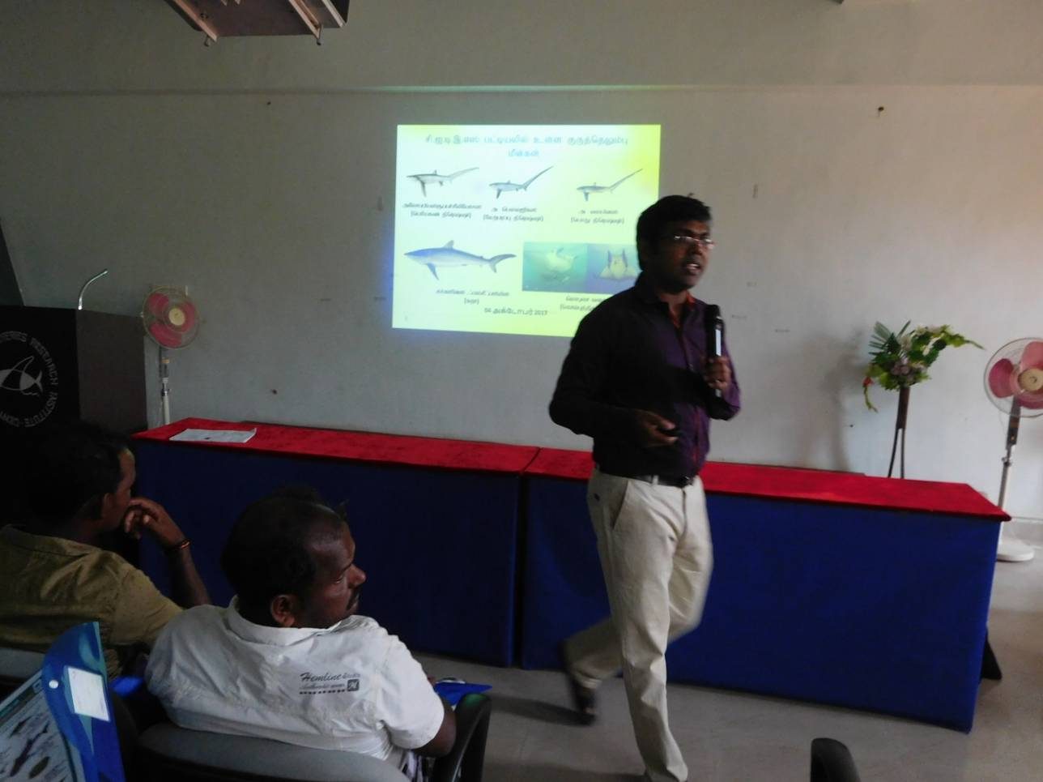
Dr. L. Ranjith delivering the lecture to the coastal fishers of Thoothukudi

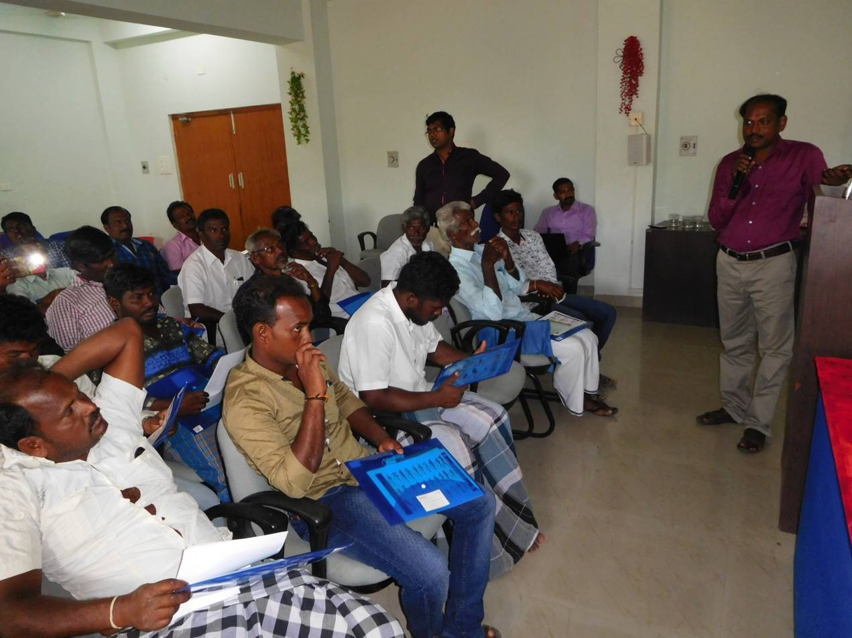
Dr. C. Kalidas delivering the lecture to the coastal fishers of Thoothukudi

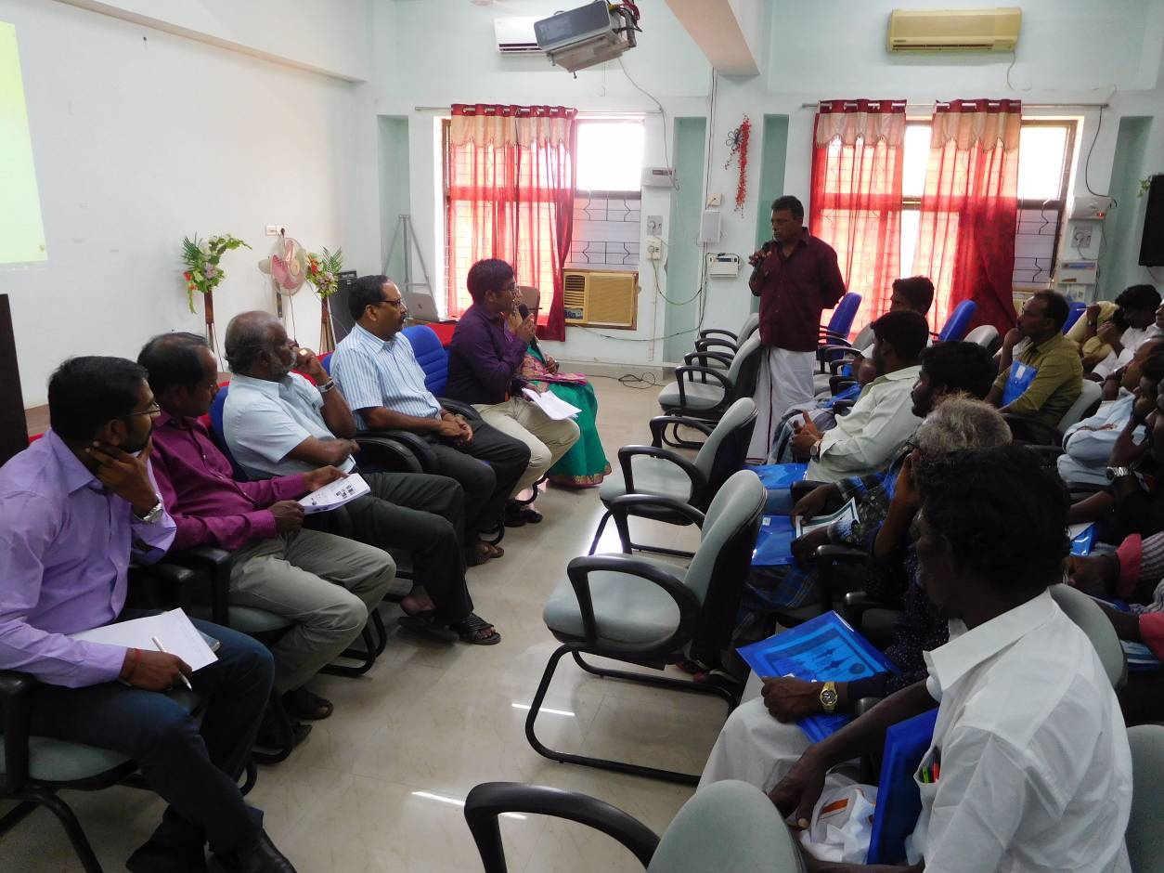
A view during the interactive session with the participants

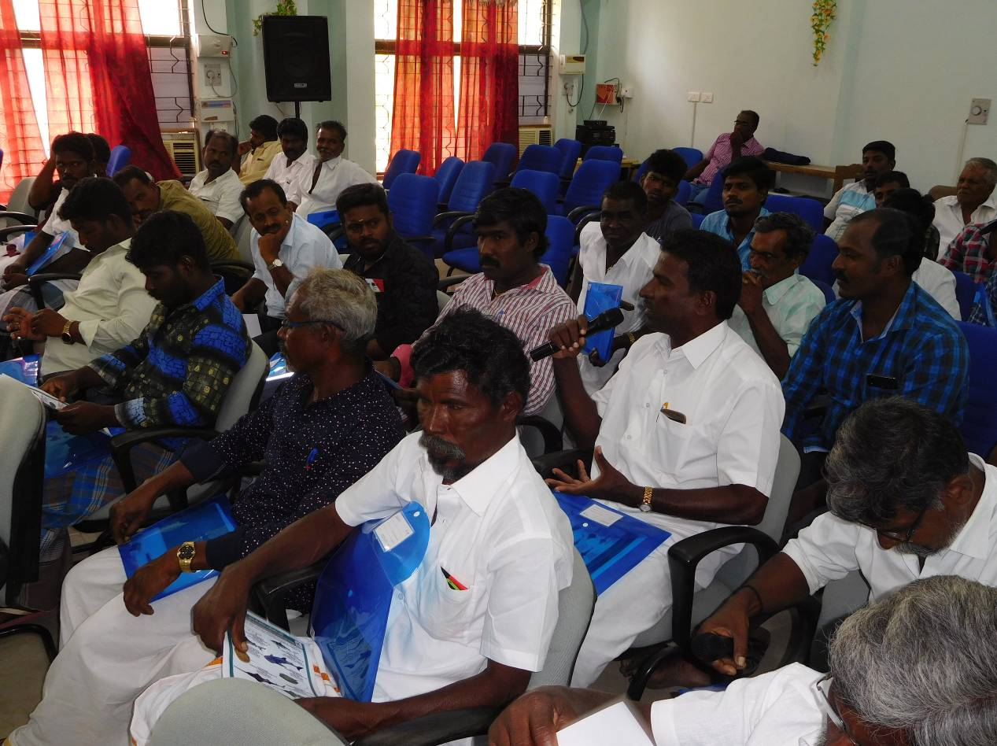
During the interactive session with the participants

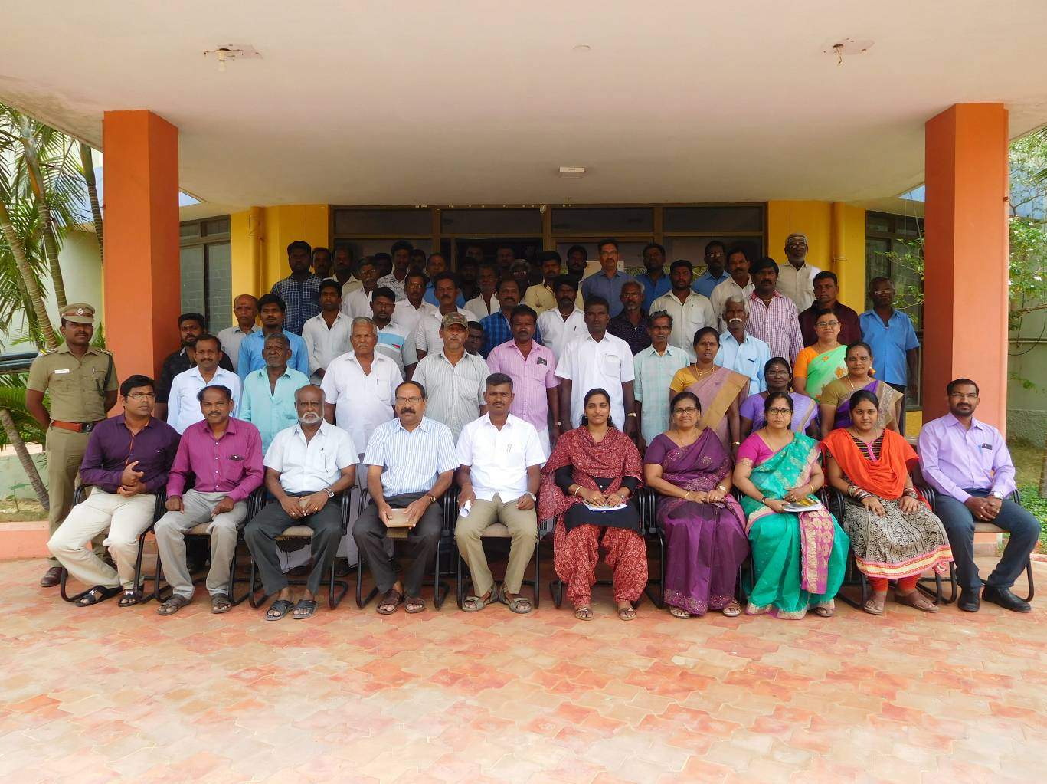
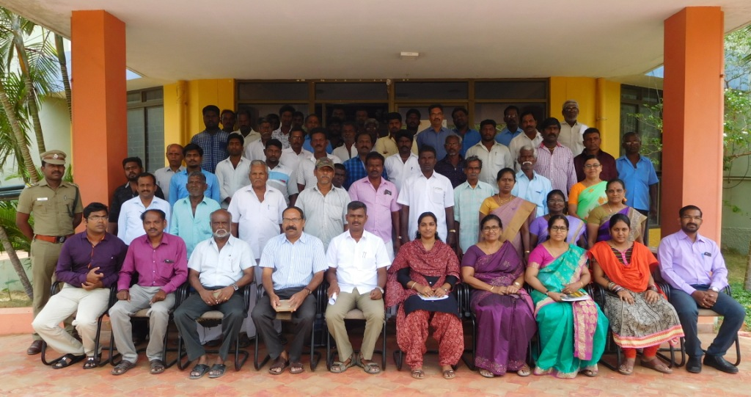
A view participants and staffs attended the awareness workshop

